Information theory

Done by: Ospan Ramazan it2-2310

Checked by: Nurkamilya Aldangarovna

Laboratory Work 1

**Problem 2**

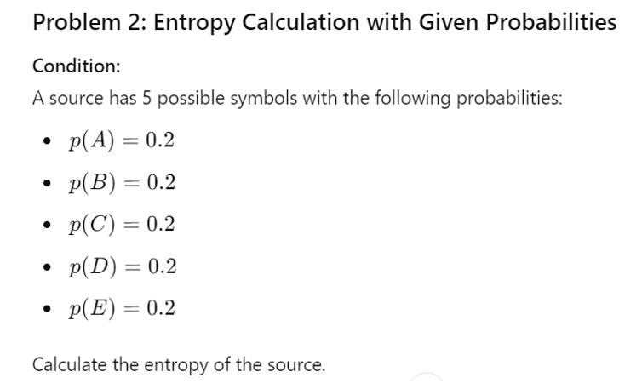

Solution

#include <iostream>

#include <cmath>

int main() {

float p = 0.2;

float log2_p = log2(p);

float symbol_etropy = -p * log2_p;

int symbol_count;

std::cout << "ввод количества символов: ";

std::cin >> symbol_count;

float entropy = symbol_count * symbol_etropy;

std::cout << "log2(" << p << ") = " << log2_p << std::endl;

std::cout << "энтропия одного символа = " << symbol_etropy << " бит" << std::endl;

std::cout << "энтропия источника = " << entropy << " бит";

}

----------------------------------------------------------------------------------------------------------------

**Review**

Entropy of one symbol = -p*log2(p)

P = symbol probability

Log2(p) = logarithm of probability on base 2

Multiplication by -1 converts a negative logarithm value to a positive entropy value

Calculation of the total entropy of the source:

source entropy = number of characters * (-p*log2(p))

Total entropy of the source:

Source entropy = 5 * 0.464386 ≈ 2.32193 бит

In this case, since all symbols have the same probability, the total entropy of the source is simply proportional to the entropy of one symbol multiplied by the number of symbols